NHS LANARKSHIRE DELIRIUM GUIDELINES

TARGET AUDIENCE | Clinicians working in all acute sites in Lanarkshire  MH&LD services NHS Lanarkshire
PATIENT GROUP | All adults aged 18 and over, in whom delirium is suspected or confirmed

Clinical Guidelines Summary
- Delirium is a serious condition that is associated with poor outcomes
- Delirium may be present in up to 20% of acute general medical patients
- Risk factors: age >65, cognitive impairment, previous delirium, hip fracture, serious illness, surgery, polypharmacy, substance misuse, frailty, stroke
- Up to 30% of cases are preventable
- Preventative measures include: good hydration & nutrition, reducing sensory deprivation, promoting mobilisation, orientation and good sleep patterns, avoiding multiple ward moves, managing pain and regulating bowels and bladder
- High risk individuals should be screened daily using 4AT and the TIME checklist if delirium is suspected
- Following diagnosis, investigations are required to identify the underlying cause
- Up to 30% of cases will have no identifiable cause
- Non-pharmacological management strategies incorporate the prevention measures mentioned above
- Additional strategies include educating patient and family, personalisation of care, tailoring interactions and environment to improve orientation, 1:1 nursing and reducing stimulation
- Pharmacological options include haloperidol, risperidone and benzodiazepines
- The risks and benefits of using medication should be discussed with the patient and family and rationale documented
- The use of legal frameworks should be considered when treating patients with delirium (use of Adults with Incapacity and Mental Health Act)
- Medication should be monitored regularly and stopped as soon as possible
- Delirium may take weeks or months to fully resolve
- At point of discharge, follow up should be arranged for those who require ongoing medication review and/or cognitive assessment

INTRODUCTION

These guidelines were developed to assist clinicians in acute sites in NHS Lanarkshire with providing consistent and evidence based management in cases of suspected and confirmed delirium in adults over the age of 18. They are based on the following:

- NICE CG103 Delirium
- HIS ‘Think Delirium’
- SIGN 157

Patients who present with Stress and Distress in Dementia, Alcohol Withdrawal, Terminal Agitation and Traumatic Brain Injury may present in a similar way to patients with delirium however their management will be different.

Therefore, please refer to more specific guidance or to the relevant specialist services for these patient groups:
- Stress and Distress in Dementia
- Management of Alcohol Withdrawal (In acute sites GMAWS is utilised)
- Terminal Agitation (Agitation at the end of life)
- Traumatic Brain Injury

CONTENTS

- What is delirium?....................................................................... Page 3
- Risk factors for delirium…………………………………………………………. Page 3
- Prevention……………………………………………………………………………… Page 4
- Diagnosis……………………………………………………………………………….. Page 5
- Non-pharmacological management ………………………………………. Page 8
- Pharmacological Management ………………………………………………. Page 8
- Capacity and Legal frameworks ……………………………………………… Page 12
- When to refer to Liaison Psychiatry ………………………………………. Page 13
- Considerations for discharge …………………………………………………. Page 13
- Cognitive impairment and dementia ……………………………………… Page 13
- Driving …………………………………………………………………………………… Page 14
- Further resources ………………………………………………………………….. Page 16

1. What is Delirium?

The International Classification of Diseases, version 11 (ICD-11) defines delirium as;

“a disturbance of attention, orientation, and awareness that develops within a short period of time, with transient symptoms that may fluctuate depending on the underlying causal condition or aetiology.”

- Delirium is a serious condition associated with poor outcomes.
- Delirium may be present in up to 20% of acute general medical patients₁
- It affects up to 50% of those who have hip fractures₁
- Up to 75% of those in intensive care may develop delirium₁

Therefore, many patients on acute sites will be at risk of developing a delirium.
THINK DELIRIUM

The duration and severity of delirium is variable and difficult to predict, and symptoms can last for weeks or months after the cause is treated₂

However, steps can be taken to prevent, diagnose and manage it when it occurs.

2. What are the risk factors for developing a delirium?

- Being elderly (65+ years old)
- History of cognitive impairment or dementia
- Frailty
- Previous episode(s) of delirium
- Stroke, neurological disease or falls
- Severe illness eg infection, urinary retention, pain, constipation, dehydration
- Injury or recent surgery, especially hip fracture
- Substance misuse; psychoactive drug use and alcohol use
- Medication: polypharmacy (>4 medications), abrupt withdrawal of medication and high risk medications (anticholinergic, opiates, benzodiazepines) See Appendix 3
- Multiple ward moves
- Sensory impairment

3. Prevention

Up to 30% of cases of delirium are preventable₃

What can we do when a patient is at risk of delirium?

When we recognize that a patient is at risk of developing a delirium there are steps we can take to reduce this risk:

- Ensuring the person is well hydrated and eating well by:
    - Offering food and drink regularly
    - Use diet and fluid charts to monitor intake
    - Ask familiar people (friends/family) to assist/prompt
    - Ensure dentures are available/fitted
- Ensure that any sensory deficits are reduced by making sure glasses and hearing aids are utilised.
- Encourage mobilisation wherever possible. There is evidence that regular movement can reduce the incidence of delirium in at risk groups.
- Promote orientation using clocks/calendar/personal items by the patient’s bedside and avoid multiple ward moves.
- Promote good sleep patterns with a quiet and low lit ward environment where possible, consider ear plugs, particularly in ICU settings, and avoid moves between wards at night time.
- Assess for pain regularly and manage appropriately.
- Regulate bladder and bowel function – prevent and manage constipation and urinary retention.
- Identify if there is a history of alcohol excess and manage this appropriately.
- Reduce polypharmacy by:
    - Reviewing all current medications – the indication, necessity, risk of withdrawing, risk of delirium.
    - In high risk areas, eg orthopaedic ward, use treatment protocols that have choices of medication which minimise risk of delirium.
- Depth of anaesthesia should be monitored in all patients aged over 60 years under general anaesthesia for surgery expected to last for more than one hour, with the aim of avoiding excessively deep anaesthesia.

4. Diagnosis

The TIME checklist is a useful tool to guide the consideration and identification of the above risks factors and preventable causes

The TIME checklist is available in Appendix 2.

- Delirium is a clinical diagnosis based on the patients’ history and presentation. There is no one test which can be used to diagnose a delirium and even if a cause has not been identified this does not rule out a delirium.

Delirium can occur prior to admission, or at any time during or after admission to hospital.

On admission, collateral history is often important in identifying delirium. Marked changes in the person’s normal presentation, that occur over the course of hours or days, may be indicative of delirium.

The Single Question to Identify Delirium (SQID) question “Do you think (name of patient) has been more confused lately?” is an easy and reliable way to identify change and to keep families and carers involved.

- Inpatients should be observed daily for any changes in their presentation
- Use the screening tool: 4AT (Appendix 1), to screen for signs of delirium in high risk patients: age >65, serious illness, cognitive impairment, previous delirium, hip fracture
- Screening (using 4AT) should also be done at admission, transitions of care, if SQID question is positive or there are any clinical concerns
- If there is a suspicion of delirium, the TIME checklist should be completed to prompt consideration of Triggers, Investigations, Management and Engagement (with patient and families)

If the assessment tool indicates delirium, the diagnosis should be made by a clinician with the expertise to do so – ideally the same person who carried out the assessment tool.

For intensive care unit settings, Confusion Assessment Method for ICU (CAM-ICU) or Intensive Care Delirium Screening Checklist (ICDSC) should be considered to help identify patients with probable delirium.

Types of Delirium

Delirium can be subcategorized into hyperactive and hypoactive delirium. Mixed delirium is when the patient fluctuates between the 2 states.

Hyperactive delirium:
- Confusion and disorientation
- Visual, auditory or tactile hallucinations
- Heightened state of arousal
- Uncooperative or aggressive behaviour in a way that is out of character for them
- Delusional beliefs
- Restless, pacing or wandering
- Sleep disturbance

Hypoactive delirium:
- Confusion and disorientation
- Withdrawn or quieter than usual
- Drowsy or sleeping more than usual
- Low mood
- Poor concentration
- Reduced appetite
- Reduced mobility

Once delirium has been identified, investigations to identify underlying causes should be arranged.

Up to 30% of cases may have no identifiable cause and normal investigation results do not exclude delirium₄

Initial Investigations:

- Physical observations/NEWS chart
- Medical review for systemic enquiry to identify potential causes
- Full Physical examination, including assessment of the skin and neurological examination
- Review bowel charts, food/fluid charts if available
- Urinalysis +/- MSSU
- Bloods – U&Es, LFTs, Bone profile, CRP, FBC, Coag, Magnesium, TFTs, drug levels (eg Lithium)
- Consider the need for chest x-ray and/or sputum sample
- ECG
- Check BM
- Have medications been stopped abruptly or started recently

CT head scans should not be used routinely as part of investigations for delirium.
However, consider the need for CT head if there is delirium in the context of:
- New focal neurological signs
- Reduced level of consciousness (not adequately explained by another cause)
- History of recent falls
- Head injury (patients of any age)
- Anticoagulation therapy
- Ongoing delirium with no identifiable cause, or features to suggest primary central nervous system pathology
- Consider a neurology referral if there are atypical features that might make you think of limbic, autoimmune or paraneoplastic encephalitis.

Diagnostic Overshadowing

In patients who have a history of psychiatric illness, delirium should not be overlooked, and clinicians should be aware of diagnostic overshadowing.

Relapses in psychiatric illnesses generally happen gradually and patients often have 'typical' symptoms. If the patient's mental state has changed very quickly, is associated with new signs of physical illness, or their symptoms are different to their usual symptoms, this can suggest delirium, rather than a relapse of mental illness.

People with mental illness are more likely to experience physical health problems than those without, and so the possibility of delirium should always be considered, and investigated appropriately.

5. Non-pharmacological Management

The practical steps noted above to prevent or reduce the risk of delirium also apply to the general principles of managing delirium.

In addition, there are other non-pharmacological steps which can be utilised such as:

- Providing information to family regarding delirium
- Completion of “Getting to Know me” documents by family/friends and staff using this information to inform care and meaningful interactions with the patient
- Adopting a flexible approach to visiting, particularly during periods when the patient is distressed. If this is not possible then facilitating phone calls or video calls with family may be helpful
- Consider one to one nursing care
- As well as using clocks and calendars, orientating the patient can also be done verbally or with signs e.g on their door, name badges, introducing yourself
- Placing familiar objects in the room (photographs, cushions and radio) can help reduce distress
- Reducing stimulation in their environment, e.g. reducing noise, light and the number of people coming in and out of the room, moving to a side room if possible

6. What are the pharmacological management options?

If the above practical steps have been taken and a patient is distressed and/or presenting a significant risk to themselves or others, then pharmacological treatments can be considered.

- Any medication presents a risk of side effects and the decision on whether to prescribe should be balanced - considering these risks versus the potential benefits
- Risks include increased risk of stroke, reduced mobility, falls, worsening of confusion and extrapyramidal side effects, particularly in elderly patients
- Decisions on whether to prescribe should be discussed with the patient or next of kin/guardian/power of attorney, particularly as some of the drugs noted here would be prescribed off-licence
- If the patient is already on an antipsychotic medication it may be appropriate for this to be increased rather than adding different types of antipsychotic. Contact Liaison Psychiatry or out of hours Duty Psychiatrist for advice regarding this
- There is increased mortality with all antipsychotic use in dementia, but low dose risperidone is arguably a better choice than haloperidol in frail elderly with delirium in this regard

HALOPERIDOL
Haloperidol is the only licenced medication for managing the symptoms of delirium₅
However, haloperidol is associated with side effects, particularly QTc prolongation and extrapyramidal side effects (dystonia, akathisia, parkinsonism, tardive dyskinesia) and may not be suitable for all patients, with elderly patients requiring particular caution. As such, haloperidol should only be prescribed when non-drug interventions have been ineffective.

Patients should have an updated ECG to check QTc prior to being prescribed haloperidol, and QTc should be monitored during the course of treatment. In regards to QTC prolongation if benefits of antipsychotics outweigh the risk for an individual patient then senior clinicians can use their clinical judgement.

Potential suitable candidates for haloperidol include:
- Younger patients with no significant cardiac history or co-morbidities
- Known QTc within the normal range (male <450ms, female <460ms)
- Patients who may require IM as well as oral medication
- Patients who have had haloperidol before and tolerated it well
- Patients who are not on other QTc prolonging medication
- Patients who do not have other risk factors for prolonged QTc (elderly, electrolyte abnormalities, extremes of weight, cardiac disease, substance misuse, family history of QTc prolongation)

Definite contraindications for using haloperidol include, but are not limited to:

- Parkinson’s Disease or Lewy Body Dementia
- Prolonged QTc or congenital Long QT syndrome
- Already prescribed QTc prolonging medication
- Recent acute myocardial infarction or uncompensated heart failure
- Uncorrected hypokalaemia

Dosage

- Haloperidol 0.5mg – 1mg, as required, maximum dose of 2mg in 24 hours, minimum 4 hours between doses
- This can be oral or IM if required – dosage is the same for IM prescription
- Offer oral first before considering IM medication

IM administration:

- IM medication is only for situations where the risk to the patient or others is deemed high and the patient is unwilling or unable to accept oral medication
- If IM route is being used, consider the need for additional legal powers (eg using the Mental Health Act or Adults with Incapacity Act)
For patients who are on QTc prolonging medication, and the clinical circumstances make the use of haloperidol with these medications unavoidable:

- Consider alternative medication options below
- Ensure the rationale for treatment is clearly documented and reflected in the patient’s individualised treatment plan
- Ensure modifiable risk factors for QTc prolongation are minimised e.g. electrolyte abnormalities
- Discontinue other drugs known to prolong QTc if possible
- Avoid extreme physical exertion
- Regular ECG monitoring will be required
- Consider discussing with cardiology, particularly if QTc is >500ms

RISPERIDONE

Risperidone is not a licenced treatment for delirium but can be effective, and is regularly used for this purpose. As it is being used off licence, discussion with patient/NOK/carer/POA/Welfare Guardian is essential and should be clearly documented.

Potential suitable candidates for risperidone:
- Elderly patients
- Frail patients
- Patients with known dementia or cognitive impairment
- Prolonged QTc – risperidone is considered to be lower risk for QTc prolongation though ECG monitoring would be advisable
- Patients who have risk factors for prolonged QTc as mentioned above
- Patients who are already prescribed this for other reasons
- When IM use is not anticipated (risperidone long-acting injection, which is the only injectable form, must never be used for delirium)

Dosage
- Risperidone 0.25mg – 0.5mg – prescribed daily or twice daily, up to maximum of 1mg in 24 hours
- Use lower dose range for elderly or frail patients initially, and dose can be titrated if required and tolerated

BENZODIAZEPINES

Benzodiazepines, such as lorazepam, can be used to manage agitation or aggression associated with delirium, although there is very limited evidence base for this. It is, however, used in clinical practice for patients with severe distress or at risk of harming themselves or others.

However, these can cause paradoxical agitation which may lead to an increase in agitation soon after administration. These risks should be carefully considered against any potential benefits in terms of reducing risks and/or distress.
Additionally, this group of medications can worsen delirium and underlying cognitive impairment.
Potential candidates for benzodiazepines include:
- Patients in whom antipsychotics are contraindicated
- Patients with Parkinson’s Disease or Lewy Body Dementia (though risk of falls should be considered)
- Patients who are antipsychotic naive
- Patients who have had adverse reactions to antipsychotics previously
- If QTc status is unknown, or suspected to be high, and ECG not possible
- If patient or family are not willing to accept the risks associated with antipsychotic use

Dosage

- Lorazepam 0.5-1mg, as required, max 2 mg in 24 hours, minimum dose interval of 4 hours
- Lower doses (0.5mg) max dose 1mg in 24 hours, for frail or elderly
- Lower dose (0.25mg) may be required for patients who are very frail or low BMI – but please note this dose is not routinely available on the wards and has cost implications so may not be readily available
- Only if the oral route is not possible and there are significant risks to the patient and/or others should the use of IM benzodiazepine be considered.
- Lorazepam can be given sublingually or IM if oral route not available/not accepted. Dosing is the same as when given orally. There is little evidence base for IM use but it is used in clinical practice.
- Only if the oral route is not possible and IM lorazepam not available and there are significant risks to the patient and/or others should the use of IM Midazolam at a dose of 2mg (max 6mg/24 hours) be considered. Only to be used in settings where appropriate monitoring can occur.
- Wait a minimum of 1 hour between intramuscular lorazepam/midazolam doses and ensure that IV flumazenil is available in case of benzodiazepine induced respiratory depression.

Need for ongoing treatment:

- The efficacy and need for ongoing treatment should be reviewed on a daily basis
- Pharmacological treatment should be in place for as little time as possible
- If continuation of medication is required on discharge, then arrangements for review and discontinuation should be made via the discharge letter

PARKINSONS/LEWY BODY DEMENTIA

For management of psychotic symptoms in patients with Parkinson’s and cognitive impairment, quetiapine is suggested by NICE, however this is an off-licence use. In clinical practice, if patients with Parkinson’s Disease or Lewy Body Dementia present with hallucinations or delusions related to delirium, quetiapine is usually the medication of choice. Please discuss such patients with Liaison Psychiatry or out of hours with the on-call Psychiatrist, for specialist advice.

7. Capacity and legal frameworks

Adults with Incapacity (Scotland) Act 2000

- Emergency sedation, when there is significant risk to the safety of the patient or others, can be given under common law
- More regular use of sedative medication requires assessment of capacity
- Patients with delirium will often lack capacity to consent to parts of their medical care and treatment and will require a Section 47 certificate (under Part 5 of the Adults with Incapacity Act), with accompanying treatment plan.
- Any Power of Attorney or Welfare Guardian should be involved in decisions about the person’s care, or the Next of Kin, particularly if they are aware of what the person’s wishes would have been.
- Use of the Covert Medication Pathway can be considered, under AWI, if compliance is an issue, as an alternative to IM medication – see specific guidance on Covert Medication Pathway

The Mental Health (Care and Treatment) (Scotland) Act 2003

- This should be considered in situations where the patient is requiring regular/anticipated restraint, use of IM medication, significant redirection or restriction of their liberty, or absconding and requiring physical intervention to return them to the ward
- Criteria for an Emergency Detention Certificate (EDC) must be met, and ideally discussed with a Mental Health Officer prior to the detention being put in place
- This can also be discussed with Liaison psychiatry in office hours, or on-call psychiatry out of hours
- FY2s and above can complete an EDC
- All EDCs must be processed through medical records and Liaison psychiatry informed as soon as possible, via telephone or online referral system, to ensure review of the EDC is carried out timeously

8. When to refer to psychiatry

A referral to Liaison Psychiatry via the Firstport referral system should be made if:

- There is severe agitation or distress unresponsive to standard measures above
- Consideration needs to be given to use of the Mental Health Act or if an Emergency Detention Certificate is in place
- There is doubt about diagnosis
- If considering medication for a patient with Parkinson’s Disease or Lewy Body Dementia

9. Considerations for discharge
- Diagnosis of delirium should be clearly recorded in the medical notes, discharge letters and coded accordingly, to ensure this is noted for future admissions
- Sedative medications should ideally be stopped prior to discharge
- If the patient is being discharged on sedative medication, appropriate follow up should be arranged, and this communicated on the discharge letter.
- Patient and relatives should be informed that delirium can take up to 6 months to fully resolve
- In patients who have experienced delirium in ICU, consideration should be given regarding follow up for psychological sequelae including cognitive impairment

10. Cognitive impairment and dementia
- Previously undetected cognitive impairment may be brought to light due to an episode of delirium, and follow up for cognitive assessment in the community on discharge may be required
- If there is concern regarding longer standing cognitive impairment or dementia, then a referral to the Community Mental Health Team should be made by the discharging medical team
- Dementia should usually not be diagnosed within 6 months of an episode of delirium, and often requires an MDT approach, so it is unlikely that Liaison psychiatry will agree to carry out assessment for a potential dementia diagnosis during an acute admission with a recent episode of delirium
- Cognitive impairment, and associated functional impairment, that occurs as a result of delirium may not resolve prior to discharge, and so functional and social work assessments may be required prior to discharge, to establish if additional social supports are required in the short to medium term.

11. Driving advice
Patients who have suffered from a Delirium should be advised not to drive until their symptoms have fully resolved and they feel safe to drive. If, at the point of discharge you are concerned regarding the patient’s fitness to drive and/or their ability to recognise this then you should refer to DVLA guidance or contact the DVLA for further advice. They can be referred for a formal driving assessment at the SMART Centre in Edinburgh.
If the patient has displayed psychotic symptoms or has ongoing cognitive deficits, then you should refer to the specific DVLA guidance available and provide the patient with the appropriate advice:
Consensus Guidelines for Clinicians; Driving and Dementia; Newcastle University (ncl.ac.uk)
Any health professional can give advice/raise concerns with the DVLA regarding driving.

References
- Scottish Intercollegiate Guidelines Network (SIGN). Risk reduction and management of delirium. Edinburgh: SIGN. 2019. (SIGN publication no. 157). [May 2023]. Available from URL: http://www.sign.ac.uk.
- Scottish Delirium Association (SDA). Delirium Management Comprehensive Pathway. SDA, 2018. [May 2023]. Available from url: SDA - Delirium pathway (signdecisionsupport.uk)
- National Institute for Health and Clinical Excellence (NICE). Delirium: diagnosis, prevention and management. London: NICE, 2023. [May 2023].Available from URL https://www.nice.org.uk/guidance/cg103
- Healthcare Improvement Scotland (HIS). Think delirium: improving the care for older people, delirium toolkit. [May 2023]. Available from url: https://www.whatdotheyknow.com/request/238377/response/593545/attach/4/Delirium%20toolkit.pdf
- Medicines and Healthcare Products Regulatory Agency (MHRA). Review of the use of haloperidol in elderly patients with acute delirium. London: MHRA, December 2021, [May 2023] Available from URL Review of the use of haloperidol in elderly patients with acute delirium - GOV.UK (www.gov.uk)

Appendices

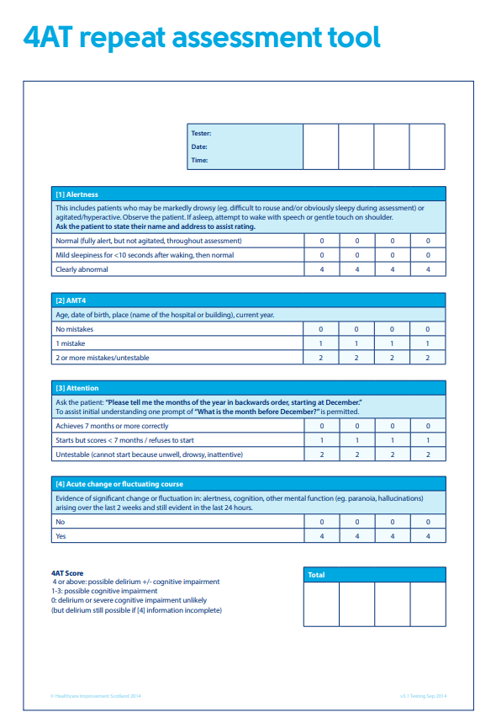
Appendix 1
Appendix 2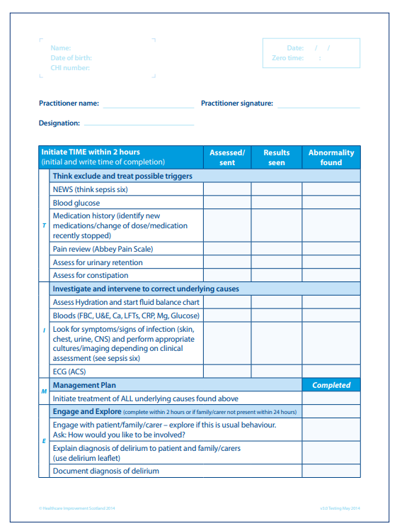

Appendix 3
Drugs which increase risk of Delirium

Drugs which increase the risk of delirium include:

Benzodiazepines
Opiates
Antiparkinsonian medications
NSAIDs
Anticonvulsant medications
Corticosteroids (e.g.Prednisolone)
Antihistamines (especially first generation e.g. Hydroxyzine)
Antispasmodics and antiemetics
Fluoroquinolone antibiotics (e.g. Ciprofloxacin)
Tricyclic antidepressants (e.g. Amitriptyline)
Antiarrhythmic medications (e.g. Digoxin – risk of toxicity)
Antihypertensive (e.g. Beta blockers)
Diuretics (e.g. Furosemide)
Theophylline
Lithium

Medications which have anticholinergic properties are a particular risk in terms of causing delirium. A table of commonly prescribed medications which may have anticholinergic properties can be found here: Anticholinergics (scot.nhs.uk) as well as suggestions for alternate medications with less anticholinergic burden.

There are useful rating scales online which can be used to assess anticholinergic burden of certain medications.

Some commonly used over the counter drugs can also increase the risk of delirium:
Diphenhydramine (e.g. Benylin®)
Chlorphenamine (e.g. Piriton®)
Promethazine (e.g. Phenergan®, Night Nurse®)
Antidiarrheal drugs
Irritable bowel syndrome drugs containing hyoscine (e.g. Buscopan®)

