Attach sticker here | Occupation: |  |  | Date:
 | Dominant Hand: R L
 | Date of Operation:
 | Operating Surgeon
 | Type of operation:
Skin graft: Yes/ No | Fingers Affected:
Previous Surgery: Yes/No | If yes details:
Pre- op Contractures: |  | Correction obtained on operating table:
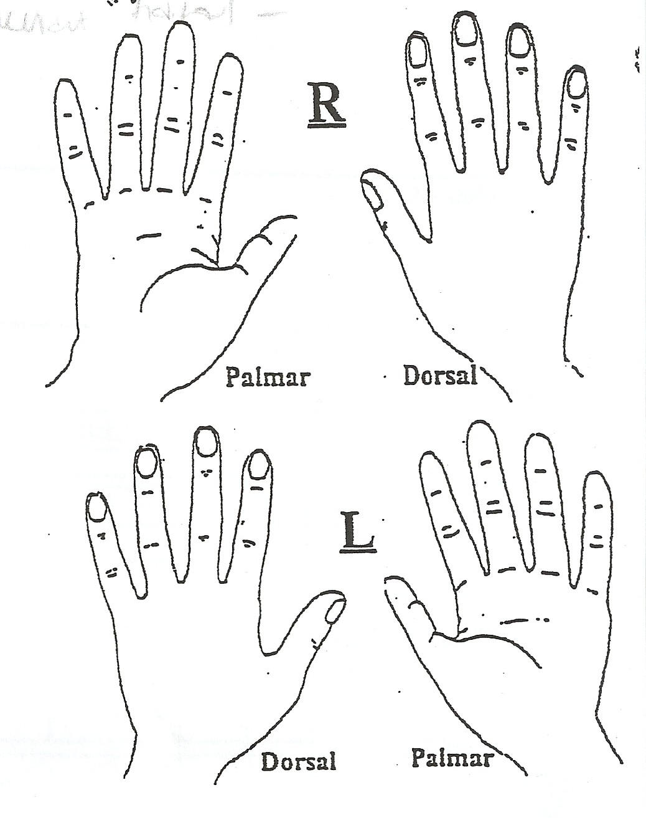  KEY  Pins & needles Loss of sensation  Hypersensitivity Amputation Oedema |  | 24hr Pattern:
 |  | Sleep:
Pain VAS:
0 1 2 3 4 5 6 7 8 9 10
Functional Restrictions
Pre op:

Present:

 |  | Social History:
 |  | Smoking/ Alcohol:
PMH:
chest / lungs / tb
heart
blood pressure
Diabetes
Epilepsy
Blood clots
Surgery
Osteoporosis
RA
Other
Drug History: |  |  | General Health:
Attach sticker here
Red Flags/ Special Questions:
Answer Yes or No. Note details where abnormal.
Unexplained Weight Loss:
History of Cancer:
Steroids:
Anticoagulants:
IVDA:
Generally unwell:
Constant non-mechanical pain
Para/anaesthesia:
Gait disturbance:
Thoracic Pain:
Yellow Flags/ Other Flags:
Answer Yes or No. Note details.
Attitudes and beliefs:
Behaviours:
Compensation:
Diagnosis:
Emotions/ Feelings/ Mood:
Family:
Work:
Other Flags (Blue, Black, Orange)

Patient Risk Assessment:
Possible Risk: Yes / No - specify if risk or possible risk identified

Consider Patient and Physiotherapy safety (environment, patient condition, e.g. bariatric), Contraindications, Precautions (e.g. pacemaker), Allergies, Pregnancy

If yes, Precaution / Prevention Measures taken:

Patient Perceptions:
Patient Expectations

Attach sticker here

Objective Examination
Wound/Scar | Oedema
Skin | Sensation
Fear Avoidant: Yes/ No
Additional Assessment:

Method of recording joint range

Dorsal___________ 0˚ = ext/flex

Palmar
R/L
Examination date
Active/Passive ( as appropriate) |  | A | P | A | P | A | P | A | P | A | P | A | P | A | P | A | P
Thumb | MCP
 | IP
 | TIP to base LF
Index | MCP
 | PIP
 | DIP
Middle | MCP
 | PIP
 | DIP
Ring | MCP
 | PIP
 | DIP
Little | MCP
 | PIP
 | DIP

Attach Sticker Here |  | Impression
Date | Problem List |  | Treatment Plan
 | □ ROM |  | 1. □ Mobilisation exercises
 | □ Oedema |  | 2. □ Passive physiological movements
 | □ Delayed wound healing |  | 3. □ Oedema management advice
 | □ Over granulation of wound |  | 4. □ Scar management
 | □ Hand Hygiene |  | 5. □ Hand hygiene
 | □ Infection |  | 6. □ Nocturnal splint
 | □ Pain |  | 7. □ Advice an education
 | □ Fear avoidance |  | 8. □
 | □ |  | 9. □
 | □ |  | 10. □

Patient agreed functional Goals/ Outcomes:
Date | Goal | Time Scale | Review Date | Achieved | Initials
 | Improve ROM
 | Reduce swelling
 | Improve understanding of surgery, healing and rehabilitation
 | Scar management
 | Achieve/ maintain ROM attained on operating table
 | Improve function
 | Return to work
 | Return to hobbies

Initial treatment/ advice given (e.g. 1, 2, 3, 4, etc... specify if and what additional)

