Catatonia Bundle [PART 1/4] – Identification and Diagnosis
Please also refer to the NHS Lothian ‘Catatonia Guideline: Assessment, Diagnosis and Management’, especially if the patient is a child, older adult, has an intellectual disability, or significant autism spectrum disorder. This and other useful documents can be found on the Catatonia intranet page: Catatonia Hub.

Patient name: Click here to enter text. CHI: Click or tap here to enter text.
Date: Click here to enter text. Assessor: Click here to enter text.

Catatonia is a syndrome of primarily psychomotor disturbances, characterized by the co-occurrence of several symptoms of decreased, increased, or abnormal psychomotor activity. Symptoms can either be persistent or fluctuating. Catatonia is typically secondary to something, which can be a physical or psychiatric cause. The severity of symptoms can vary within and between patients, but this bundle aims to empower teams with the tools and structures required to manage even severe presentations. Prompt identification and treatment is the best way to avoid progression to such a situation. Definitions of the below signs can be found at: ICD-11

DIAGNOSING CATATONIA BY ICD-11 CRITERIA
Discuss with those who have seen the patient over the last 24 hours and tick what has been present:
Decreased activity |  | Abnormal activity |  | Increased activity
☐ | Staring | ☐ | Grimacing | ☐ | Extreme hyperactivity or agitation for no reason with non-purposeful movements and/or uncontrollable, extreme emotional reactions; impulsivity (sudden engagement in inappropriate behaviour without provocation); combativeness (striking out against others usually in an undirected manner, with or without the potential for injury).
☐ | Ambitendency | ☐ | Mannerisms
☐ | Negativism | ☐ | Posturing
☐ | Stupor | ☐ | Stereotypy
☐ | Mutism | ☐ | Rigidity
 |  | ☐ | Echo-phenomenon
 |  | ☐ | Verbigeration
 |  | ☐ | Waxy flexibility
 |  | ☐ | Catalepsy

- Three or more of the above boxes are ticked? [☐]
- The symptoms are significantly impairing or severe enough to cause medical complications [☐]
- Symptoms are not better accounted for by a primary movement disorder [☐]
Are all three of the above ticked? If so, a diagnosis of catatonia can be made: Choose an item.

ASSESSING THE SEVERITY OF CATATONIA
In adults: Bush-Francis Catatonia Rating Scale – Score [Click here to enter text.] (can be calculated online at MDCalc)
In children: Paediatric Catatonia Rating Scale – Score [Click here to enter text.]

THE LORAZEPAM CHALLENGE
Example protocol from Bush et al (1996b), Stenaert et al (2014):
- Assess catatonic features prior to challenge using structured assessment and examination
- Administer lorazepam 1-2mg IV, or 1-2mg IM, or 2mg oral
- Re-assess catatonic features after 5 minutes (after IV), 15 minutes (after IM) or 30 minutes following oral. A positive response is considered a 50% reduction in score on a standardised catatonia instrument.
- If there is not a positive response, consider a further lorazepam challenge (ideally parenterally) and re-assess.
Was the challenge positive? Choose an item.

In catatonia, lorazepam should not be sedating but may reduce ‘increased activity’ symptoms if these are present. A positive response is both supportive of a diagnosis of catatonia, and gives some indication of whether the catatonia will improve with regular lorazepam. Monitor for oversedation.
Catatonia Bundle [PART 2/4] – Investigating for a cause
Identifying the cause/driver of catatonia is crucial, with there being many potential physical and psychiatric causes. Once the cause has been identified, it is essential to treat this, as well as the catatonia.
PHYSICAL EXAM | NEUROLOGICAL EXAM | UNIVERSAL INVESTIGATIONS
Tick when done [☐]  Notable findings:  [Click to add text] | Tick when done [☐]  Notable findings:  [Click to add text] | FBC, U&Es, LFTs, CK, CRP, TFTs, B12, Folate, Ca²⁺/Mg²⁺/Phos, iron studies, urinary drug screen, ECG. Consider what drugs have been started, stopped, or had their dose changed.
Tick when done [☐]  Notable findings:  [Click to add text] | Tick when done [☐]  Notable findings:  [Click to add text] | Tick when done [☐]  Notable findings:  Click here to enter text.
The degree of ‘work-up’ is a clinical decision, involving weighing-up the potential risks and benefits of each test. Other investigations may be indicated based on the clinical presentation, examination features and past medical history. Such investigations may include: syphilis serology, a BBV screen, NMDA and VGKC antibodies, CT/MRI head, EEG, and LP. The potential physical health causes of catatonia span infective, inflammatory, metabolic, neurological and degenerative processes – so discussion with specialists may be required. Many different psychiatric presentations can be the cause of catatonic symptoms, including psychosis, mania, mood disorders, anxiety disorders, OCD, PTSD, and others. Catatonia can also occur secondary to autism alone, and may be conceptualised as a form of stress response, therefore indicating more of a psychosocial assessment. Older patients are more likely to have a physical health cause than younger patients.

Identified cause of catatonia: Choose an item.. Working diagnosis of cause of catatonia Click here to enter text.:

PHYSICAL HEALTH CONSIDERATIONS / MONITORING
While the patient is catatonic, ensure the following physical health risks are considered on an ongoing basis:
Dehydration | Regular vital signs. Chart fluid intake. Monitor renal function as indicated. Some patients require enhanced care-rounding to push fluid intake.
Malnutrition | Monitor weight. Chart food intake. Consider refeeding bloods. Low threshold for dietetic opinion. In severe cases patients may progress to requiring artificial feeding (e.g. nasogastric).
Pressure ulcers and skin breakdown | Calculate Waterlow score. Monitor vulnerable skin and pressure areas. Consider the use of air-flow mattresses and/or regular turning. Consider catheterisation if incontinent/immobile.
Muscle contractures | Promote movement and repositioning. Examine for contracture development and consider physiotherapy referral if at risk.
Venous thrombus | Patients may be at risk of development of DVT and PE. Consider prophylactic dalteparin, or if contraindicated, TED stockings.
Aspiration | May require monitoring around mealtimes due to slowing, altered swallow or frenzied episodes of eating. Consider oral hygiene measures and food/fluid texture modification.
Urinary retention | Low threshold for physical examination and bladder scanning. Development of retention should prompt systematic assessment for a cause, including UTI and constipation.
Constipation | Immobility, reduced fluid/dietary intake and reduced laxative intake (e.g. if refusing or struggling to take larger volumes) may contribute. Start a bowel chart.
Oral/Eye care | Consider hydrating eye drops for those with reduced blink rate. Artificial saliva, mouthcare and treatment of any oral thrush can make eating more comfortable and appealing.
Pain | Pain may not be reported spontaneously, and the Abbey Pain Scale can be utilised. A number of aspects of catatonia may be painful. Have a low threshold for simple analgesia.
Inability to report new physical health issues | Regular physical examination and consideration within the context of the patient’s past medical history. Consider increased frequency of blood testing.

Food and fluid chart in place? [☐] Bowel chart in place? [☐] Current weight obtained? [☐]
Have you considered enhanced care-rounding to monitor physical state and intake of food/fluids: Choose an item.
Have you considered a frequency chart to record time spent exhibiting specific catatonic features: Choose an item.

Catatonia Bundle [PART 3/4] – MDT & Treatment
Physiotherapy | Promotion of safe mobility, with dynamic assessment around aids required and falls risk. If risk of contractures, advice may be around positioning and postural management
Occupational Therapy | Environmental considerations to reduce falls risk. Advise on equipment or adaptations to environment. Meaningful engagement/activity with a focus on a sensory approach
Dietetics | Especially if low oral intake, dietetics can help maximise benefit from what intake there is. See malnutrition risks above
Speech & Language Therapy | Assessment if swallow is impacted (may need variable advice dependent on degree of alertness). Advice on food/fluid texture. Assistance with communication strategies
Psychology | Especially useful in catatonia secondary to autism spectrum disorder. All patients may benefit from case formulation and consideration of needs
Music/Art Therapy | No current evidence base, so case-by-case consideration. May reduce distress, promote meaningful contact, provide stimulation and aid maintenance of day/night cycle.
Malignant catatonia involves autonomic disturbance and may be fatal. Immediate treatment is vital. If adequate control is not achieved with benzodiazepines in 48hours (less if deterioration in clinical state) then urgent ECT is indicated. Depending on the levels of physical instability, care in a medical HDU or ICU environment may be required.
Considered involvement of the above MDT members: [☐]

TREATMENT OF CATATONIA ITSELF:
!
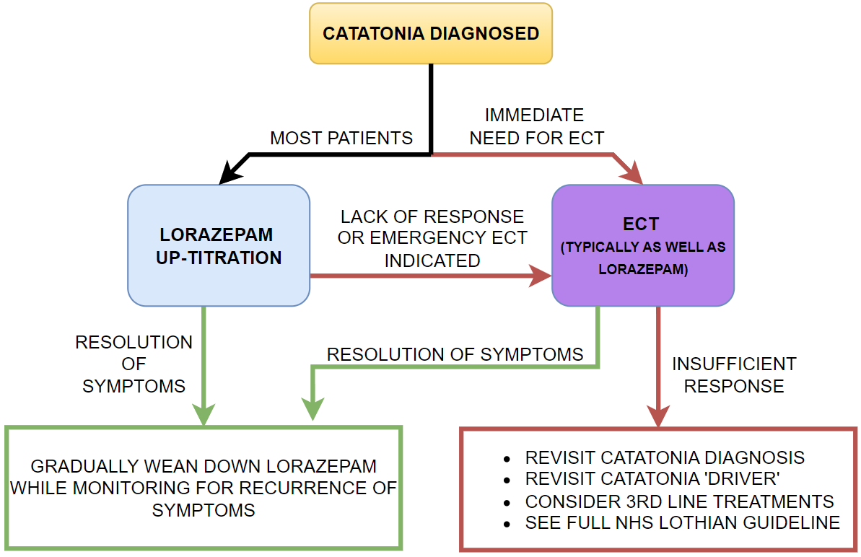

INDICATIONS FOR ECT

-Malignant catatonia
-Insufficient oral intake
-Inability to reach an effective lorazepam dose
-Lack of or incomplete response to lorazepam
-Loss of response to lorazepam over time

LORAZEPAM UP-TITRATION
Adult patients without contraindications should be started on 1mg four times daily, or 2mg twice daily. Those over 65 or with premature frailty may be started on 1mg twice daily. Given the expectation that oral intake and activity may be best ~30-60 minutes after administration, timings may be chosen to maximize intake at mealtimes. The dose should be increased at 2-to-3-day intervals until there is adequate response (and some areas suggest more rapid increases e.g. up by 2-4mg every 1-2 days). After 2mg four times daily is reached, doses can either be given more often than four times per day, or the individual doses can be increased above 2mg.

Some patients may be unable to take lorazepam orally, which may be due to negativism, psychosis, agitation, poor swallow or declining oral intake. In this case administration can be via IM/IV routes. Rarely doses up to 48mg per day have been required for some patients, but patient tolerance for higher doses of lorazepam will vary, and close physical monitoring for sedation is essential. Flumazenil should be available if giving high doses. Any patients prescribed high doses of lorazepam should have consultant oversight and consideration of risks against benefits. There is often a high initial response rate, but this is not always maintained. Loss of initial improvement, requiring increased dose to achieve similar benefit, often heralds the need for ECT.

Catatonia Bundle [PART 4/4] – Dignity, QoL, Family, Legal Considerations

PATIENT DIGNITY AND QUALITY OF LIFE
Depending on the degree of catatonia, symptoms, cause and individual, patients can have hugely varying recollections of being catatonic. It is important that at all times we continue to speak with patients as if they can understand what we are saying, and provide explanations for their care and treatment. Orientation to where they are, what is happening, and reassurance, should be offered. The complexity of the language used should be tailored to each individual patient.
Where possible, informed by any known prior wishes or from discussion with family, care should be personalised to the patient’s preferences and needs. This may be relevant around decisions like whether to place a urinary catheter, or how to best approach other activities of daily living.
Given patients who are catatonic may be terrified of what is happening, familiar and comforting objects can be placed in their bed space. Consideration may be given to periods of stimulation via music, purposeful interaction with staff/family, or a favoured TV/radio programme. Some patients may wish for and benefit from chaplaincy input.
Considered [☐]

FAMILY
For family members, a relative’s catatonia can be very strange and confusing, and many of the potential features could be upsetting for family to witness. There are a number of potential sources of information that they can be directed to (also available via the catatonia intranet page: Catatonia Hub.
- Royal College of Psychiatrists page on catatonia: Linked here
- University College London information leaflets for patients and family: Linked here
- Some family may wish to know more of the evidence base for treatments, which is summarized in detail in the 2023 British Association for Psychopharmacology consensus guideline: Linked here
Some family members may find it beneficial to see this bundle, to appreciate the systematic and thorough approach being undertaken for their relative. Having the full MDT ‘on board’ and being engaged with their own role in the patient’s care can also be reassuring. It may be that carer supports can be signposted.

Consider asking family to fill in a Getting To Know Me form for their relative, so that care and interactions they receive from the MDT can be personalised, and preferences can be considered.
Considered [☐]

LEGAL ASPECTS
Does the patient have an AWI s47 and Annex 5? Choose an item.
Does the patient have a welfare Power of Attorney / Guardian? Choose an item.
Is the patient subject to the Mental Health Act? Choose an item.
If detained, does the patient have a named person? Choose an item.
Does the patient have an Advanced Directive or documented prior preferences for care? Choose an item.

Please scan this document in full to SCI store. Tick when done [☐]

Trak backslash ‘\catatonia’ can be used at ward rounds to review progress and treatment

