Occupational Therapy Service

**Buying a Wrist Splint –** Patient information leaflet

**Wrist Splints**

This leaflet gives some simple advice on buying a wrist support.

The examples in this leaflet are suggestions and will give you an idea of what a wrist splint should look like.

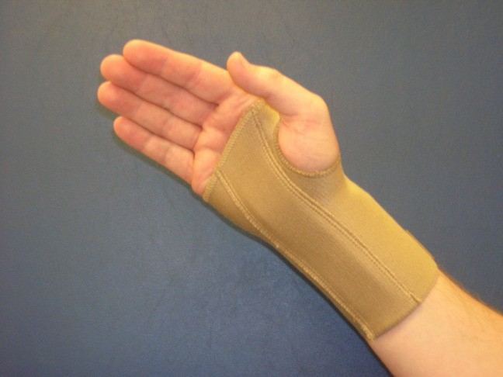

Figure 1

If you are going to use your splint to treat Carpal Tunnel Syndrome, look for one that states it is designed for that purpose. Ideally it should have a gentle bend in the metal bar. WEAR THE SPLINT IN BED AT NIGHT .

A Standard Wrist Splint

Your wrist splint should have a metal bar in it to limit wrist movement. It should

not limit your thumb or finger movement (Figure 1).

**Does it have to be a certain design?**

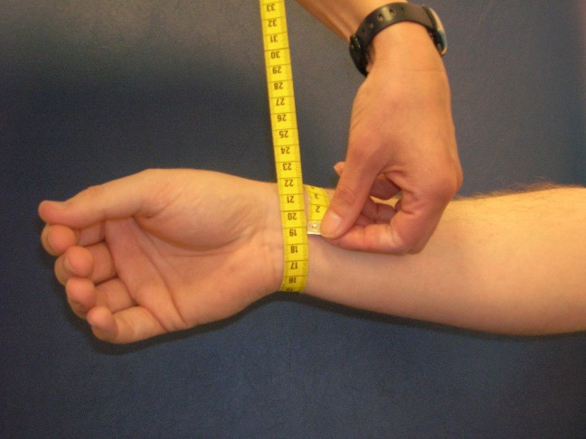

Figure 2

Measuring around the wrist

Wrist splints are supplied in small, medium, large or extra large sizes. The size

required is usually based on measuring around the wrist with a tape measure (Figure 2). Different suppliers may use different methods to size so always check.

**How are wrist splints sized?**

Continued overleaf

**Where do I get a splint from?**

You can order wrist splints online or from a Pharmacy/Chemist. Please check with your local branch.

You can also order from the following companies. Other stockists and suppliers are available.

**Promedics – Tel:** 01475 746400 Order online: [http://www.promedics.co.uk](http://www.promedics.co.uk/)

**Performance Health – Tel:** 03448 730 035 Order online: [http://www.performancehealth.co.uk](http://www.performancehealth.co.uk/)

**Amazon** [http://www.amazon.co.uk](http://www.amazon.co.uk/)

Please follow the manufacturer’s instructions for use and care of your splint.

This leaflet is also available on request in other formats by phoning 01387 272711 or emailing [dumf-uhb.patient-information@nhs.net.](mailto:dumf-uhb.patient-information@nhs.net)

NHS Dumfries and Galloway would like to acknowledge NHS Fife for the content of this leaflet. Produced by Occupational Therapy Service (v1) 2020